

**Written exam on Advanced Course in Electrical Power Systems**

**26 August 2016 (9:30 – 13:30 hrs)**

**General Information**

* *The exam consists of 5 main questions and sub-questions.*
* *There are in total 6 pages.*
* *The weightage of each question is mentioned in the parenthesis.*
* *Please provide sufficient text description and reference to textbooks and equations so your method of solution is clear and easy to follow. Statements and results will only give credit if explained thoroughly*

**Helping Aids**

*All usual aids (like textbook, lecture presentation, programmable calculator or pc) are permitted.*

**Exercise 1 (22%)**

A TSO company orders busbar phase conductors in an HV equipment factory. These are made of cylindrical tubes of aluminium terminated by a corona bell in each end, see example of corona bell and busbar system (bell not visible in right picture) in figure 1.

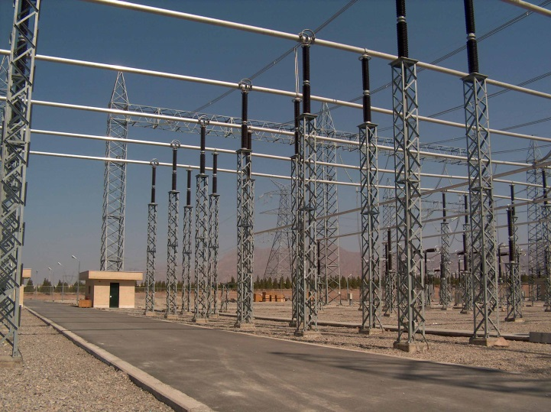

Figure 1: Corona bell (left) and busbar system (right)

This exercise only relates to one single busbar for one single phase (i.e. the influence from other phases can be neglected, except for sub-question e).

Among the possible standard dimensions to choose from for the cylindrical busbar conductors one with a radius of r1 = 180 mm is chosen.

The TSO wants to dimension the busbar system (we are, as said before, only looking at one phase in this exercise) in an *optimal* (optimal here relates to the principles for this as described in KUFFEL’s textbook) way with regards to electric field stress.

a) Calculate the optimum radius R1 of the corona bell

Next step is to analyze which voltage this busbar can be used for without having corona discharges on the cylindrical busbar conductors. It can be assumed that the maximum tolerable electric field strength in air is 15 kV/cm to avoid corona.

b) Develop, *step by step*, by means of the law of Gauss, the electric field distribution for coaxial cylindrical conductors (i.e. the busbar conductor) with inner radius r1 and outer radius r2 (i.e. make the mathematical expression for E(r)). Compare with the textbook (KUFFEL) result for this.

c) Develop, by means of the result from b) an expression for the maximum electric field strength Emax for coaxial cylindrical conductors. Check with the textbook again.

d) Use the result from c) to determine the *highest voltage for equipment Vm* as defined by IEC for the busbar discussed in the above (again; we focus ONLY on one single phase!)

e) In reality we have three-phase systems. What should be done to take into account this fact when designing the busbars (i.e. now we imagine we will design the busbars for one full three-phase system as shown in figure 1, right – just give a few lines of text explaining most important issues)?

**Exercise 2 (18%)**

Distance protection is applied for a parallel line (two circuits in the same tower) as shown in figure 2.

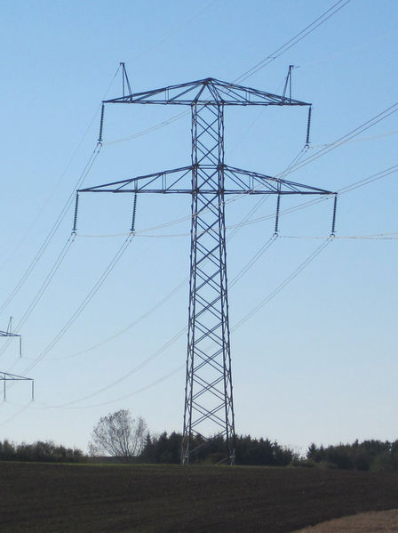

Figure 2: Energinet.dk DONAU transmission tower. The left circuit is pronounced circuit 1 and the right circuit pronounced circuit 2.

The pictures (figure 2) are only to assist the student to have an idea of the practical relation of the following questions. The line can be considered ideally transposed and has only single-ended infeed. Both circuits are in operation and part of a meshed transmission system.

All fair and well-motivated and well explained simplifications are of course acceptable.

a) Determine the relative measuring error (in %) for a distance relay in the sending end (i.e. the end with the infeed) in circuit 1 when a two-phase fault occurs in a location being 30 % of the full line length as seen from the sending end of circuit 2.

b) Determine the relative measuring error (in %) for a distance relay in the sending end (i.e. the end with the infeed) in circuit 1 when a single-phase to earth fault occurs in a location being 40 % of the full line length as seen from the sending end of circuit 1.

c) How can modern numerical distance relays solve the problem with the measuring errors in parallel lines (just explain with a few lines of text)?

**Exercise 3 (20%)**

1. Why does a power system need reactive power compensation? (4 %)
2. Draw a circuit of a STATCOM and explain its working principles. (8 %)
3. What is the flicker in a power system? What are the origins of the flicker and what are the consequences of the flicker? (8 %)

**Exercise 4 (20%)**

1. Two identical lines (same geometry, same material, same length, etc…) are installed in different points of an electrical network. One of the lines is connected to a strong node (high short-circuit power), whereas the other is connected to a weak node (low short-circuit power). The two lines are energized for the same voltage instant (equal point of wave). Answer to the following question regarding the energization of the two lines. Remember to justify your answers.
   1. Which line has a higher overvoltage during the energisation transient? (5%)
   2. Which line goes through a longer electromagnetic transient? (5%)
2. Different types of models exist for overhead lines and underground cables, with the choice depending on the type of phenomena under study. Enumerate three aspects that have to be considered when simulation electromagnetic phenomena, which are not considered when doing steady-state studies. Remember to justify your choices. (5%)
3. A 20km cable is connected to a 10km OHL as shown in the figure below. The electrical parameters of the cable and OHL are:

Cable: R=0 Ω/km; L=0.5 mH/km; C=0.2 μF/km

OHL: R=0 Ω/km; L=2 mH/km; C=12 nF/km



i. Calculate the value of all reflection and refraction coefficients. (2.5%)

ii. Using pu, how much is the voltage seen at the end of the cable, when the wave reaches that point for the first time? Assume that the switching closes when the voltage crosses 0.5pu. (2.5%)

**Exercise 5 (20%)**

1. For a 4 bus system, an incomplete nodal admittance matrix is given below. Find the missing admittance elements and write down the complete Ybus matrix. **(4%)**

    

1. The data for a 3 bus power system is given in the Table below. The series impedance and shunt admittance of each line are 0.03+j0.1 pu and j0.04 pu respectively. Bus 1 is the slack bus. Applying Newton-Raphson load flow method, calculate the Jacobian matrix after the first iteration. Assume a flat start () for those buses where voltages are not specified and base MVA as 100MVA. Show your calculations. **(10%)**

|  |  |  |  |  |  |  |  |
| --- | --- | --- | --- | --- | --- | --- | --- |
| Bus No. | Generation | | Load | | Voltage | Bus Type |  |
| Pg (MW) | Qg (MVaR) | PL  (MW) | QL  (MVaR) |  |
| 1 | - | - | 100 | 50 |  | Slack |  |
| 2 | 150 | - | - | - |  | PV |  |
| 3 | - | - | 120 | 50 | - | PQ |  |

1. The incremental fuel costs of two generators are given by

C1 = 0.06P12 + 20P1 + 200 €/hour

C2 = 0.10P22 + 15P2 + 300 €/hour

The minimum and maximum generation of both units is 10MW and 100MW. The generators supply the load profile as shown in Fig. below. Calculate the a) total cost of generation for the day in Euros (€) subjected to optimal operation and b) operating cost in €/kWh for the day considered. **(6%)**

